1. Cultural

2. Political/policies (eg. delhi ka odd even)

3. Geographical

4. Covid related

5. Industrial etc

6. Kuch aur bhi

India is the worst-polluted country in the world. India, with 83.2 micrograms per cubic metre (μg/m3), had the highest population-weighted annual average PM2.5 exposures in 2019. The World Health Organisation Air Quality Guideline puts this value at 10 μg/m3.The top five polluted countries in the world are India (83.2 μg/m3), Nepal (83.1 μg/m3), Niger (80.1 μg/m3), Qatar (76 μg/m3) and Nigeria (70.4 μg/m3).

1. **Cultural**
2. **Political/policies**

Political Rally in WB, MP election 23rd March

1. **Geographical**

Stubble burning

1. **Covid**

Lockdown

1. **Industrial**

(Got closed - Lockdown)

1. **Etc etc**

* In general India wide lockdown se AQI kam hua
* **Madhya Pradesh**
  + **Bhopal is a highly polluted city due to the amount of traffic on its streets, the exponential rise in industrial output and the construction industry.**
  + **It also houses the Bharath Heavy Electricals Limited (BHEL), which is one of the largest engineering companies in India that manufactures coal-fired power plant boilers (among many other heavy machinery). Mandideep is another industrial suburb to the south of the city, and is the largest industrial area in the state of Madhya Pradesh, with exports worth tens of million per year. Industries in this estate include Hindustan Electro Graphite (HEG), Lupin Laboratories, and Eicher tractors. The Hindustan Electro Graphite (HEG) is the largest graphite electrode plant in the world and is the largest industrial company in the state of Madhya Pradesh.**
* **Haryana**
  + [**Local sources of pollution in UP, Haryana and Delhi primary reason for poor air quality: EPCA (indiatimes.com)**](https://economictimes.indiatimes.com/news/politics-and-nation/local-sources-of-pollution-in-up-haryana-and-delhi-primary-reason-for-poor-air-quality-epca/articleshow/71593674.cms)
  + As per the above article, major sources of pollution in Haryana are mostly the local sources
  + The AQI is going towards poor levels. In Karnal and Kurukshetra, stubble burning seems to be one of the key reasons, but in Gurugram and Faridabad, there are local factors responsible for the pollution.
  + The air quality of cities falling under districts, such as Bhiwani and Rohtak, having very small areas under paddy cultivation, was better than the areas under paddy cultivation, clearly pointing that stubble burning was the main cause of pollution here.
  + The analysis of the data points towards a steady surge in farm fires, affecting the quality of air in Haryana cities, especially those under paddy belts of the state.
  + Also the total farm fires were reported to increase from sept.2020 to oct.2020 ( can use this fact if the data shows justifies it)
  + Apart from farm fires, industrial pollution too is adding to the problem in Faridabad, Gurugram, Sonipat, Karnal, Panipat, and Yamunanagar.

Important articles and theory justifying our assumption

Finding the key dates -

* January 30: India’s first Covid-19 patient — a 20-year-old medical student who just came back from Wuhan in China — reported in Kerala’s Thrissur district.
* March 10: A total of 50 Covid-19 cases reported in India, with infections doubling in just 4 days. Thirteen states and UTs in India have reported at least one Covid-19 case.
* India also bans entry of foreigners and suspends all visas from March 13 to April 15.
* March 22: Upon a call by Prime Minister Narendra Modi, a 14-hour voluntary lockdown called ‘Janata Curfew’ was observed in India.
* March 25: A nationwide lockdown across India is imposed till April 14, with only essential services kept out of its purview.
* March 26: On the second day of the lockdown, India witnesses migrant labourers walking hundreds of kilometres along highways to reach their native villages.
* April 14: Prime Minister Modi extends the 21-day lockdown to May 3. 10,000 confirmed cases are recorded.
* May 1: Home Ministry extends lockdown for two weeks starting May 4 with zone-wise restrictions. Divides districts into red, orange and green zones on the basis of cases. Shramik Special trains started for stranded migrant workers.
* May 7: Phase 1 of Vande Bharat mission to evacuate nearly 15,000 Indians stranded abroad begins. 50,000 confirmed cases reported in India.
* May 17: MHA extends lockdown till May 31, allows inter-state movement of passenger vehicles, buses with mutual consent of states. With nearly 86,000 cases, India overtakes China in terms of the total number of cases reported.
* May 19: Total Covid-19 cases in India cross 1 lakh.
* May 25: Domestic flight services resume in a calibrated manner, with only 30% of regular schedules.
* June 8: Phased reopening begins, with Unlock 1.0 guidelines coming into force, as India records more than 2,50,000 COVID-19 cases and 7200 deaths. Centre allows re-opening of malls, hotels, restaurants and places of worship.
* June 12: India overtakes UK to become 4th worst coronavirus-hit country, with over 3 lakh cases.
* June 27: Total cases cross 5 lakh. After reporting 100,000 cases on May 19, India adds 100,000 cases in 15, 10, 8 and 5 days respectively to bring the total number of cases to half a million.
* July 1: Unlock 2.0 guidelines come into force, with relaxations in night curfew, provision for more domestic flights and trains, and clearance for more than five people in a shop.
* July 6: India overtakes Russia to become third worst coronavirus-hit country, with 6.97 lakh cases. The US had more than 28 lakh cases, while Brazil had close to 16 lakh.
* July 17: International commercial flights resume as India establishes individual bilateral bubbles with France and the US. India’s total Covid-19 cases cross 10 lakh. Death toll stands at 25,600.
* August 1: Phase 3.0 of Unlock comes into force, with govt allowing gymnasiums and yoga centres to function, and revoking the night curfew order.
* August 22: The Indian Council of Medical Research reports more than one million diagnostic tests for Covid-19, with India overtaking Russia in terms of total number of samples tested till now. With 34.5 million tests having been conducted till now, India ranks third in the world. Only China (90.4 million) and the United States (74.7 million) tested more.
* September 7: India overtakes Brazil to emerge as the country with the second largest number of people infected with novel coronavirus, recording 41.13 lakh confirmed infections.Metro services resume in a graded manner across the country as per Union Home Ministry’s Unlock-4 guidelines. Commercial metro services had stopped on March 24.
* September 12: India breaks its own record in fresh Covid-19 cases, records another highest single-day spike in infections, with 97,570 people found coronavirus positive in 24 hours.
* September 16: The number of confirmed cases of novel coronavirus crossed the five million (50 lakh) mark on Tuesday, with the addition of more than 90,123 new detections. The last one million cases have been added in just 11 days. India closes gap with the US, which has 6.8 million cases (68.77 lakh) so far.
* September 17: The number of active cases of novel coronavirus in the country crossed the one million (ten lakh) mark on Wednesday. These are the people who are yet to recover from the disease, and thus require medical attention, and are also the ones who can spread the infection.
* September 21: After remaining shut for the past six months, schools partially reopened in several states
* to enable students studying in Classes 9 to 12 to visit their institutions on a voluntary basis for taking guidance from their teachers.
* September 30: MHA issues Unlock 5.0 guidelines, allows cinemas and multiplexes to open with 50 per cent capacity from October 15. It says states and Union Territories can take a decision on whether to open schools; removes limits on outdoor gatherings while allowing indoors gatherings with 50 per cent capacity.
* December 19: India’s coronavirus numbers cross 1 crore-mark.
* January 16: India begins one of the world’s biggest coronavirus vaccination programmes.
* February 19: India completes one crore vaccinations in 34 days, becoming the second-fastest in the world after the United States.
* March 1: Second phase of vaccination drive begins. All people above the age of 60 and those between 45 and 59 with specific comorbidities are eligible. People can now register on the Co-Win 2.0 portal.
* March 15: India crosses the milestone of 3.15 crore vaccinations.
* March 21: Maharashtra reports 30,535 cases in a single day.
* March 22: India reports 46,951 cases in a single day — the highest spike since November.

**Important paper which can be used as a reference** -

[Reduced air pollution during COVID-19: Learnings for sustainability from Indian Cities - ScienceDirect](https://www.sciencedirect.com/science/article/pii/S2589791820300220)

This paper contains a case study for pollution vs covid cases for 2 cities . We may expect that the trend should be the same for any other city with some minor differences.

[Positive effects of COVID-19 lockdown on air quality of industrial cities (Ankleshwar and Vapi) of Western India | Scientific Reports (nature.com)](https://www.nature.com/articles/s41598-021-83393-9)

This paper has the impact of lockdown on the air quality index (AQI) and other pollutants one month pre-lockdown and post-lockdown.

[Improved air quality and associated mortalities in India under COVID-19 lockdown (nih.gov)](https://www.ncbi.nlm.nih.gov/pmc/articles/PMC7590817/)[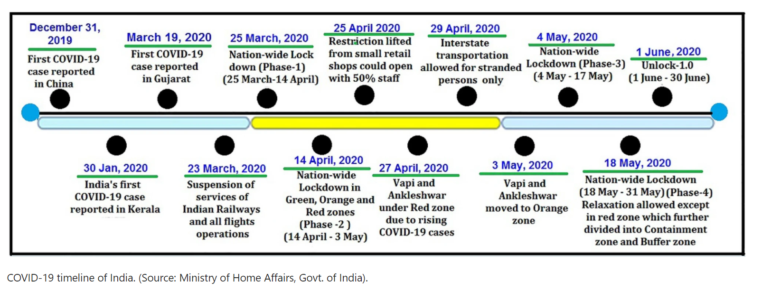](https://www.nature.com/articles/s41598-021-83393-9)

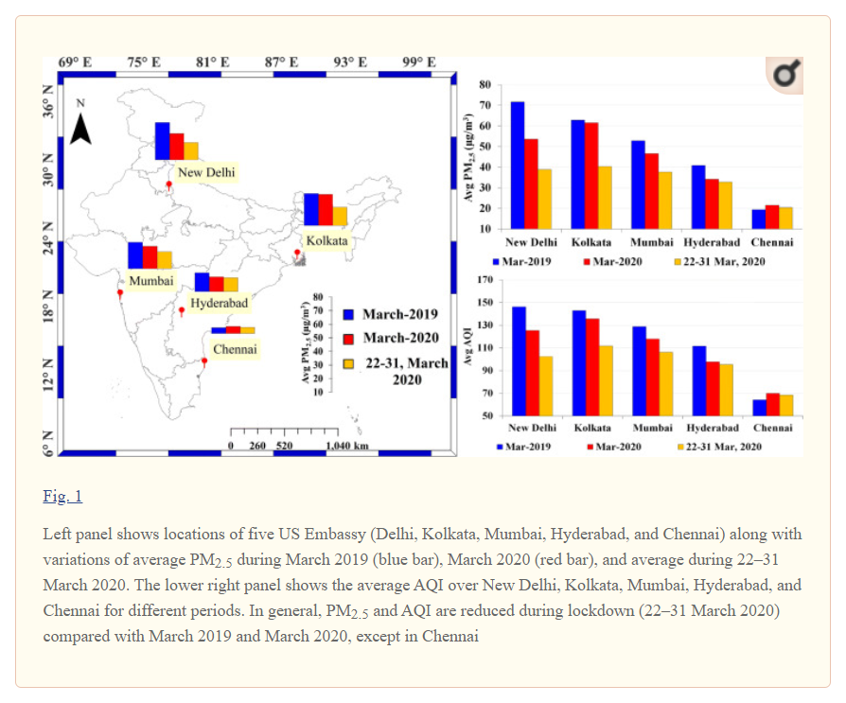

The average concentration of PM2.5 before lockdown was higher in comparison with the concentration after lockdown. The PM2.5 concentration in Kolkata is reduced by 34.52%, and 27.57% in Delhi, capital of India. In general, PM2.5 is much higher throughout the year in the northern parts of India especially in the Indo-Gangetic Plains (IGP). During pre-monsoon (March–June), winter season (December–January), and crop residue burning seasons (mid-October to mid-November), PM2.5 varies in a range of 400–800 μgm/m3 (Sarkar et al. 2018, 2019). In Mumbai, Chennai, and Hyderabad, PM2.5 was reduced by 19.25%, 5.40%, and 3.99%, respectively. The dominance of westerly wind from arid and semi arid regions and lower temperature along the Indo-Gangetic plains in the month of March, the average concentration of PM2.5 remains higher in comparison to other cities. The proximity of Mumbai and Chennai to the sea, the air mass mostly reaches from the sea surface during March and the PM2.5, is lower in comparison with Delhi and Kolkata. Similar changes are also observed in the Air Quality Index (AQI) which is a function of PM2.5 and other emissions. The improvement in air quality is clearly observed mainly due to lockdown during 22–31 March 2020.

<https://www.thehindu.com/news/national/coronavirus-lockdown-air-quality-improves-in-over-90-cities/article31201247.ece>